List of Local, State, and Federal Representatives for Malcolm Community

Local Charles County officials representing your address in Waldorf, MD 20601—including the County Commissioners and other key county representatives:
Reuben B. Collins II – County Commissioner President (At-Large)
Email: collinsr@charlescountymd.gov, commissioner@charlescountymd.gov
La Plata, MD, USA
President, Board of County Commissioners (Democrat) – County Government Building, La Plata charlescountydems.org

Ralph E. Patterson II – County Commissioner (District 4)
Email: pattersr@charlescountymd.gov
La Plata, MD, USA
Vice-President, Board of County Commissioners (Democrat) – County Government Building, La Plata charlescountydems.org

Gilbert O. Bowling III – County Commissioner (District 1)
Email: bowlingg@charlescountymd.gov
La Plata, MD, USA
Member, Board of County Commissioners (Democrat) – County Government Building, La Plata charlescountydems.org

Thomasina O. Coates – County Commissioner (District 2)
Email: coatest@charlescountymd.gov
La Plata, MD, USA
Member, Board of County Commissioners (Democrat) – County Government Building, La Plata charlescountydems.org

Amanda M. Stewart – County Commissioner (District 3); stewarta@charlescountymd.gov
Email: stewarta@charlescountymd.gov
La Plata, MD, USA
Member, Board of County Commissioners (Democrat) – County Government Building, La Plata

Charles County Commissioners District Map:
https://www.charlescountymd.gov/government/charles-county-commissioners/commissioner-district-map
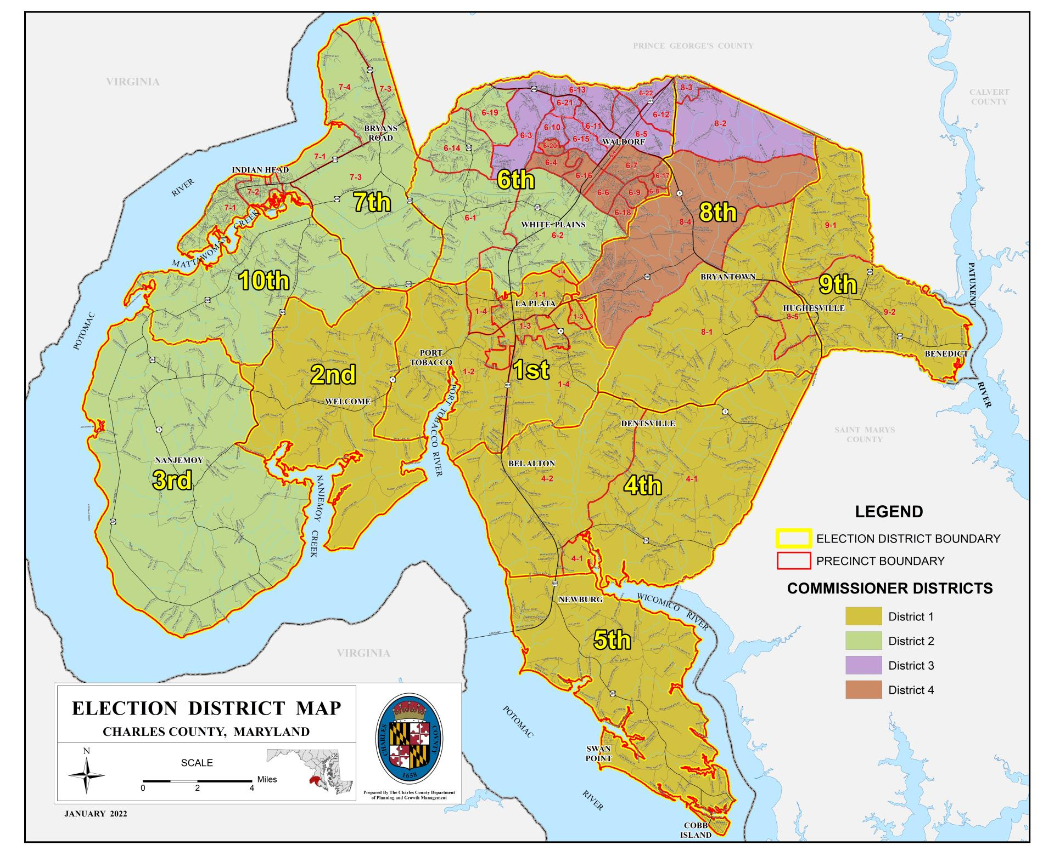

Federal and State-Level Representatives:

Level | Officeholder | Chamber/Role | Contact Info
Federal | Angela Alsobrooks | U.S. Senator | (202) 224-4524
Federal | Christopher Van Hollen | U.S. Senator | (202) 224-4654
Federal | Steny Hoyer | U.S. Representative (MD-5) | (202) 225-4131
State | Arthur C. Ellis | State Senator (District 28) | (410) 841-3616 or toll-free ext. 3616; arthur.ellis@senate.state.md.us
State | Debra Davis | State Delegate | (410) 841-3337 ext. 3337; debra.davis@house.state.md.us
State | Edith J. Patterson | State Delegate | (410) 841-3247 ext. 3247; edith.patterson@house.state.md.us
State | C. T. Wilson | State Delegate | (410) 841-3325 ext. 3325; ct.wilson@house.state.md.us

